Exercise 7: Cardiac Development
28-Hour and 48-Hour Chick Embryos and Sections

Student Learning Objectives.

1. Students will further their skills in working with live chicken embryos, with serial sectioned chicken embryos, with three-dimensional models of the chick and with internet sources.

2. Students will learn to identify the cardiovascular changes that occur between 28 and 48 hours of embryonic development in the chick.

Introduction

The heart is the first organ to function in the embryo and the circulatory system is the first functional system. The circulatory system is built so that the blood leaving the heart is pumped into the arteries, flows through the capillary beds to feed the tissues, is recovered in the veins, and then returned to the heart. In the adult there are parallel systems from the right ventricle of the heart to the lungs and from the left ventricle to the rest of the body. The reason that the cardiovascular system forms so early is that the embryo must switch from nutrient diffusion to active nutrient transport before it can get very big.

The commitment of the cells which have the capacity to form the heart, or the heart field, occurs during cleavage and gastrulation. Presumptive heart cells are specified but not determined in the epiblast. Like all mesodermal cells, the cells of the heart field undergo epithelial to mesenchymal transition and then migrate through the primitive groove. Heart mesenchyme migrate together near the node. They migrate into the blastocoel early in gastrulation and thereby assemble in the ventral portion of the mesoderm. The more anterior outflow tract-forming cells migrate in first, and the more posterior inflow tract-forming cells migrate in last. As organogenesis proceeds, the presumptive heart endocardial cells are found in the splanchnic mesoderm that is associated with the endoderm.

Development of the heart can be broken down into three steps: 1. Heart Tube Formation, 2. Looping and 3. Chamber Formation. Early on the second day of development in the chick, the formation of the heart tube begins when cardiogenic mesoderm migrates out of the mesodermal layer of the splanchnopleure towards the endoderm to form two endocardial tubes on either side of the midline. At the same time the endoderm is folding inward. The endoderm continues folding inward until it forms its own tube, which drags the two endocardial primordia close to each other. The endocardial tubes are surrounded by myocardial progenitors recruited from the splanchnic mesoderm during this movement. When the endocardial tubes get close enough, they fuse together. If you mess with endoderm migration or signaling, you end up with two hearts.

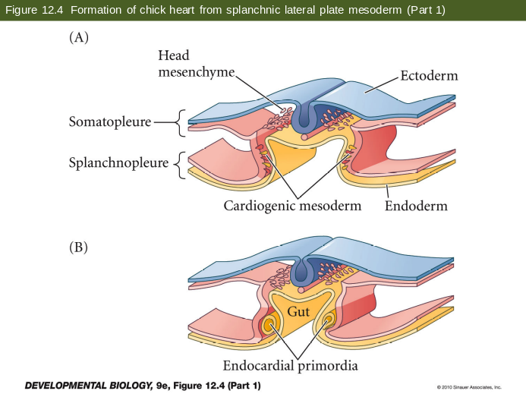

The cell and molecular mechanisms that control heart tube formation include the shift to expression of cadherins in the splanchnic mesoderm cells causing formation of an epithelial sheet for their inward migration. This is a mesenchymal to epithelial transition. The presumptive endocardial cells undergo EMT to migrate away from the sheet and another MET to form tubes. The cells in the original mesodermal sheet form the myocardium. The myocardial epithelium fuses first and the two endocardial tubes exist together for a period before fusing. Both the rostral end (outflow) and caudal end (inflow) remain as unfused double tubes. The heart beat starts spontaneously as myocardial cells express the sodium-calcium pump, well before fusion is complete.

Looping requires: cytoskeletal rearrangement, extracellular matrix remodeling and asymmetric cell division on different sides of the heart tube. Left-right asymmetry is due to Nodal and Pitx2 expression. The formation of heart valves is essential to keep the blood from flowing back into the chamber it was just ejected from. The septa separate the two atria and the two ventricles. The truncus arteriosis, or outflow tract, also becomes septated allowing one great artery to flow from right ventricle to lungs and the other from left ventricle to the body. The tricuspid valve is between the right atrium and right ventricle. The pulmonary or pulmonic valve is between the right ventricle and the pulmonary artery. The mitral valve is between the left atrium and left ventricle. The aortic valve is between the left ventricle and the aorta. Steps: 1. Endocardial cushions form and fuse, 2. Septa grow towards cushion, and 3. Valves form from myocardium. In utero, the foramen ovale allows right left shunting of blood. All of the blood must circulate outside of the embryo for oxygenation.

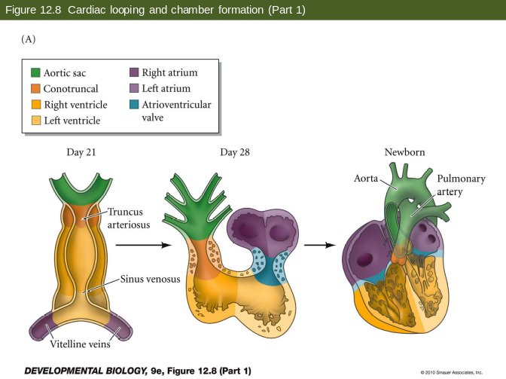

The vessels form independently of the heart. They form for embryonic needs as much as adult. The embryo must get nutrition before there is a GI tract, must circulate oxygen before there are lungs, and must excrete waste before there are kidneys. They do these through links to extraembryonic membranes. The vessels are constrained by evolution. Mammals still extend vessels to empty yolk sac. Birds and mammals also build six aortic arches as if we had gills, eventually settling on a single arch. The vessels must also adapt to the laws of fluid dynamics. Large vessels move fluid with low resistance, whereas diffusion requires small volumes and slow flow. Therefore, we create a highly organized system to adapt floe to needs. Variation in size of vessels controls volume of flow and superbranching smaller vessels control speed. Vasculogenesis is the de novo differentiation of mesoderm into endothelium. It is followed by the endothelium recruiting smooth muscle cell coat. Angiogenesis is the growth and remodeling of the 1st vessels in response to blood flow and tissue-derived recruitment signals.

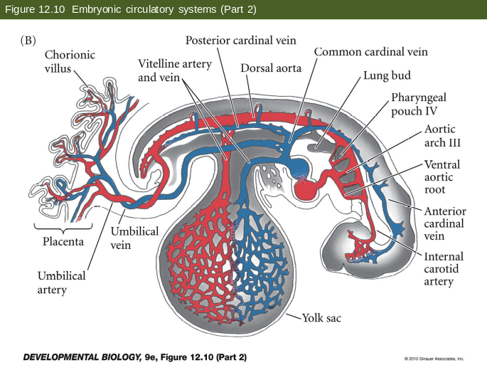
Procedure

A. The 28- and 48--hour chick embryo whole mounts

1. Preparation of live embryos for viewing

a. Removal of the embryo from the chicken egg
1. Get a fertilized egg from the incubator and take it to your bench
2. Very gently roll the egg to free the internal membranes from the inside of the shell
3. Wait a moment for the air space to re-establish at the very top of the horizontal egg
4. Use your small scissors to gently tap on the top of the egg until a small crack appears
5. Place the egg in your large petrie dish and cut around the egg shell – be careful to cut only shell!
6. Continue to cut until the yolk comes free into the dish

b. Removal of the embryo from the yolk
1. Find the embryo on the yolk
2. Using the forceps, place the filter paper ring over the embryo. Don’t let paper touch the embryo.
3. Using your scissor gently cut the membrane around the outside of the filter paper
4. Transfer the filter paper and embryo into the small petrie dish filled with buffer. Swirl gently to remove excess yolk.
5. When free of yolk, place the embryo onto a glass microscope slide and add a drop of dye into the hole punch of the filter paper.

2. Place the 28-hour chick embryo preparations on your microscope and orient yourself to its structure. Compare the live animals to pictorial data from the web so that you can identify the following structures in the image data that you collect today.

a. To orient the embryo, find these structures surrounding the embryo: the area pellucida, area opaca, cranial and caudal ends of embryo. Point out the cranial, caudal, dorsal, ventral, left and right axes of the embryo.

b. Find these structures: neural tube, notochord, somites, Henson’s Node and primitive streak.

c. Find the presumptive heart tube, outflow tract and inflow tract.

3. Place the 48-hour chick embryo preparations on your microscope and orient yourself to its structure. Compare the live animals to pictorial data from the web so that you can identify the following structures in the image data that you collect today.

a. To orient the embryo, find these structures surrounding the embryo: the area pellucida, area opaca, cranial and caudal ends of embryo. Point out the cranial, caudal, dorsal, ventral, left and right axes of the embryo.

b. Find these structures: brain, spinal cord, somites, eye, ear, trunk flexion point, cranial flexion point.

c. Find the heart tube, outflow tract, inflow tract, dorsal aorta, and extraembryonic vessels

